Report on the Heritage Value of the House at 198 Church Street, Almonte

I. Property Identification

Location: 198 Church Street
Part of Lot 43, Anderson Section, Town of Almonte, Plan 6262
(For a map, see….[reference to Mississippi Mills website])

Owners: Alexander and Elizabeth Gillis
198 Church Street, Almonte, ON K0A 1A0

Type of Property: Residence

Photographs:

Photo 1 – above: Although the date of this photograph is not known, it is most probably from the 1910s. The porch may well be the original one. It also appears that there is no gingerbread on the centre gable.

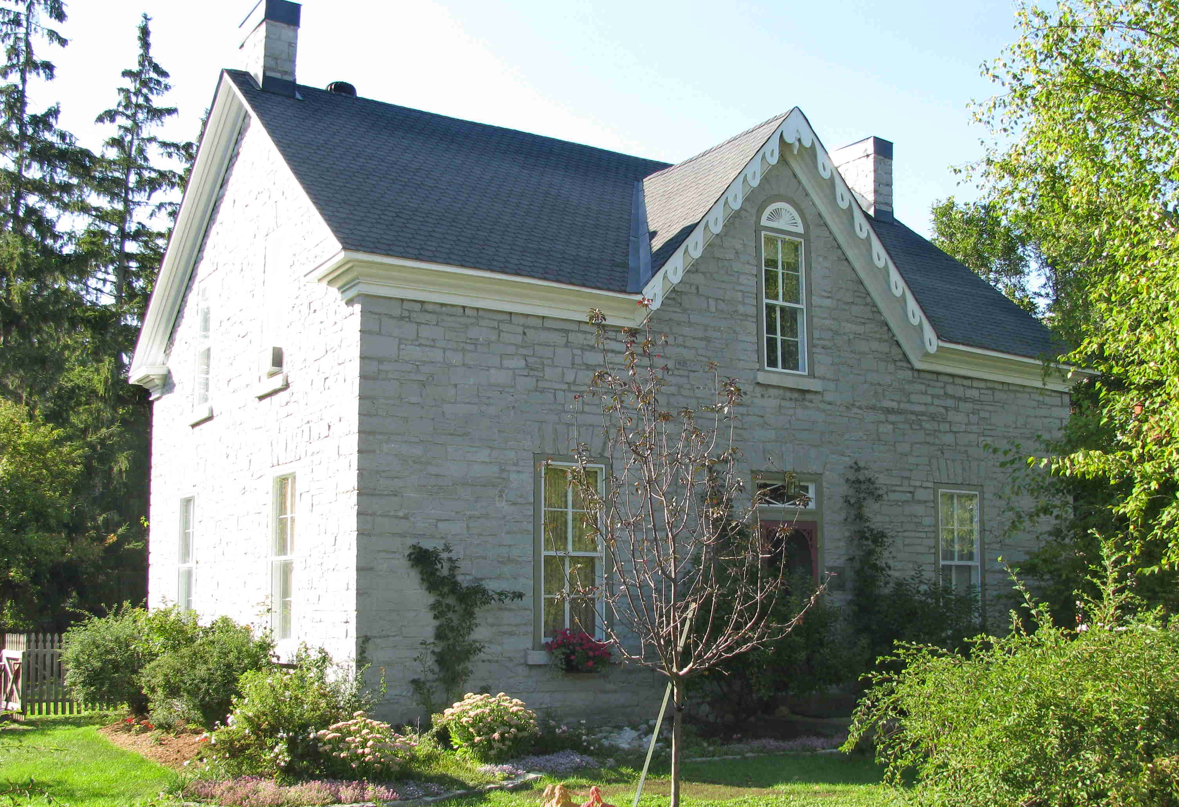
Photo 2 – above: The date of this photograph is unknown. It shows the more substantial porch and the symmetry of the side windows.

Photo 3 – below: This shows the house as it was in [date]. The lines and symmetry of the Ontario cottage style are more apparent without the porch. The transom detail is also more visible.

– 3 –

II. Physical Description of Property

Design Value

(i) Architectural Style

The residence on this property reflects the “Ontario Cottage” style of architecture, which figured prominently throughout Upper Canada/southern Ontario in the period 1830-1880, especially as farmhouses. This style is characterized by a 1½-storey structure with an emphasis on horizontal lines, symmetry, a centre gable with window, returned eaves on the end gables, and moderate ornamentation on the cornice. A front porch was also common.

The stone house at 198 Church Street, built in 1866, is a very good example of that Ontario Cottage style. The original stone building’s outer dimensions are 28’x37’. The east-facing front façade has three bays on the lower level. The rectangular windows are double-sash, with four over four lights. The front door (not original) is centred in the façade, with a rectangular, clear, original glass transom window. The transom has a diamond-shaped light. The sash window in the front gable has two over two lights and is topped with semi-circular, ornamented woodwork. The two-bay, north and south ends of the house have two windows on the lower level and two on the upper, symmetrically positioned. Like the front, they are sash-type, with four over four lights. All of the sashes in the windows are original wood with some original glass. The windows had shutters, but these were removed by the present owners. (See photos 2 and 3.)

The roof is of medium pitch, with two original stone chimneys situated at either end of the roof peak. The cornice features crown molding and returned eaves at the end gables. The centre gable is set off by a gingerbread gableboard. The cornice is currently painted white.

Most of the back of the original house is no longer visible. A 26’x18’, 1-storey gabled extension (tail) was added, probably around the turn of the 20th century, making the pattern of the house T-shaped. This was a common addition to this house style. A chimney at the end of the extension was removed by the current owners. The tail was originally clad with double brick. The brick exterior was covered with board and batten veneer in 2007, and is currently stained with a heritage grey colour. Two gabled dormers were also added to the north side. Other renovations were made in the mid-1980s, including a gabled garage that ties in structurally with the back extension. Clad with board and batten, it is stained the same colour as the extension.

The original house had a porch running most of the length of the front façade. (A photograph, probably from the 1910s, shows a modest wooden porch, but this is believed not to be the original one. See photo 1.) A later photograph shows another porch which was much heavier-looking and thrust farther out toward the street. It had short squarish columns on a much sturdier base of either brick or concrete. Such substantial porches were popular in the 1910s and 20s, in part to make the porch structurally more sound, but undoubtedly to make the house look more grand. (See photo 2.) At present, the house does not have a porch. The front door entrance is protected by a small, modern, curved acrylic canopy supported by a steel frame.

– 4 –

(ii) Construction Technique and Materials

The house has rubble masonry foundation walls. The supporting walls of the original house are of grey, roughly squared limestone laid in a broken course. The windows have cut stone lintels.

None of the original roofing material exists. Currently, the roof is covered with black, scalloped shingles.

Historical/Associative Value

(i) Direct Association with a Historic Theme

The Ontario Cottage style reflects more the rural character of the surrounding countryside of Ramsay Township. William and Jane Snedden had the house at 198 Church Street built, but it is not known by whom. It is similar to the frame farmhouse on the 9th Concession of Ramsay Township where their family lived before moving into Almonte. As a farming family that “moved into town,” they brought with them the house style that they knew, and in the process upgraded from a frame house to a handsome stone one. Wittingly or unwittingly, they brought the architecture of the countryside to the town. The Snedden/Gillis house is not only an important example of this style of residential architecture; it is one of the few instances of it within the town of Almonte, and exceptional in that it is a stone building.

(ii) Association with Notable People in the Area

Through the years, many notable families have called 198 Church Street home: a well-known and successful farming family with additional commercial interests, a co-owner of a foundry, a member of the Naismith family, and a long-serving town Councillor.

The Sneddens, one of the original families to settle in Ramsay Township in 1819-20, remain well known in the area. From the early days of settlement, members of the family had several farms, a lumber mill, and the well known “Stopping Place” (inn/tavern) on the 9th Concession near present-day Blakeney. Up to the mid-1990s, eight generations of Sneddens had lived in Ramsay Township, with family members still working one of the original family farms.

William Snedden, the son of David Snedden, was born in 1826 and raised on a farm on the 7th Concession (Lot 24) of Ramsay Township. He became the owner of that farm in 1847 at age 21, later passing it on to his brother John when William married Jane McRostie. William and Jane Snedden then moved to a farm located on the 9th Concession (Lot 9) and worked the land there until 1866. It is not known why William, Jane and family moved to Almonte. It has been referred to as William’s “retirement home,” although he was only 41 years of age when he moved.

Upon William’s death in 1902, the house stayed within the Snedden family. Jane Snedden and her daughter Agnes, and possibly some other members of their extended family, continued to live there. When Jane Snedden died in 1912, Agnes became the owner of the house and sold it the following year to Thompson Kirby, co-owner of the Kir-Ben foundry in Almonte. In 1918, Thompson Kirby sold the house to Greville Toshack and Mansfield Snedden. It is not known, though, who lived in the house at

– 5 –

that time. In 1929, the executors of Mansfield Snedden granted ownership of the house to the Royal Trust Company, which remained the owner throughout the Depression and Second World War years.

Although the connection between the Sneddens and 198 Church Street came to an end in 1929, a Snedden tie to the original property surfaced 14 years later. In 1906, the original property was severed and a house was built on that lot. That property, 190 Church Street, was sold to David Wilfred Snedden in 1943. His executors sold the property in 1982. Hence, Sneddens were directly connected to the original property, in one way or another, for most of the time between 1866 and 1982.

Edgar Lowry bought the house at 198 Church Street in 1946, and sold it to Elinor and Emile Callow in 1953. Elinor Callow granted the house to her daughter, Emily, in 1975. Emily subsequently married David E. Naismith, from a well known family with long-standing ties to the Almonte area. (James Naismith, the inventor of basketball, was born in Almonte in 1861.) The Naismiths sold the house in 1982 to Mary Kitts who then sold to Roy and Pearl Lacey. The present owners, since September 1988, are Colonel (retired) Alexander Gillis and his wife Elizabeth. Alexander Gillis has been a long-serving Councillor for the Town of Almonte (1992 to 1997) and, subsequently, the amalgamated Town of Mississippi Mills (1998 to the present).

Contextual Value

(i) Link with Property’s Surroundings

When the house was built, Country Street was the southern perimeter of Almonte. To the south, the view would have been primarily of farmland. With its location and architectural style, the house stood for many decades as a cultural and architectural link between town and countryside. The intersection of Country and Church Streets would also have been a main one. Going north on Church Street from Country Street would have taken people to churches, a school and the train station. Farmers coming from the south and east with produce for Almonte may well have made their way toward that intersection. The house would consequently have been well known, standing as one of the markers at the southern edge of town. Today the house stands in one of the oldest residential areas of Almonte, acting as a bookend on an attractive residential street.

Since the Second World War, Almonte has expanded considerably to the south. Almost a century elapsed between the time that William and Jane Snedden had their house built and the more recent housing development. Rather than a link with the countryside, the stone house at 198 Church Street now represents a noticeable dividing point between mid-19th and mid-20th century Almonte.

III. Present Status of Building

The house is in very good condition and well maintained. It has been faithfully restored and many of the original features are intact. From a structural point of view, there are no apparent risks to the integrity of the building.

– 6 –

Most of the houses in the vicinity are in good condition. There are no vacant lots nearby that would be open to newer development. It would appear, therefore, that the surroundings will remain much as they are today for many years to come.

IV. Recording Information

(i) Sources
(a) Documents
Records of the Land Registry Office for Lanark County
Marilyn Snedden, The Snedden Saga: From Lanarkshire to Lanark County (General Store Publishing House: Burnstown, Ontario) 1994, 243 pages.
Doors Open Mississippi Mills: Snedden/Gillis house, September 27, 2008.
Report by Susan Algie, under the auspices of the Local Advisory Committee on Architectural Conservation and the Ontario Ministry of Culture and Recreation, August 1977.
Almonte: Faces and Places 1880-1980, Corporation of the Town of Almonte, 1980.

(b) Reference Books
Thomas F. McIlwraith, Looking for Old Ontario: Two Centuries of Landscape Change (University of Toronto Press: Toronto, Buffalo, London) 1997, 400 pages.
Steven J. Phillips, Old-House Dictionary: An Illustrated Guide to American Domestic Architecture 1600 to 1940 (John Wiley & Sons Inc.: New York) 1994, 237 pages.

(c) Meetings
Marilyn Snedden, September 30, 2009
Alex Gillis, October 15, 2009 and November 19, 2009

(ii) Recorder and date of submission

John Hannigan prepared this report and submitted it to the Heritage Committee of the Town of Mississippi Mills on December 16, 2009.

